Lan Technologies facility sharing of information between all the locally connected stations

Direct communication is achieved through an addressing scheme

Each station is assigned a unique mac addressing scheme.

Ethernet mac addresses are 48 bit in length.

The header of the file contains the addresses of the sender and receiver

There are three methods of communication – Unicast (station – station), broadcast (station to all stations), multicast (station to some stations)

To extend lans there are three ways, repeaters, bridges and routers

Bridge routing strategies routing fixing or address learning

Routing fixing means the data is stored on a look-at list about where each file is.

Address learning means all the files are being allocated to an look-at list dynamically (the machine learns of all address fields starting from boot-time)

Advantages of bridges:

Parnellism

Optimised performance

Problems with Lans:

Not universal – Cannot communicate with lan of different hdmi language

Internetworking is the solution

It introduces new hardware and software for all devices to us.

Applied by a router

A router is an internetworking computer of its own right

Allows the universal rule of the internetworking to work

The internetworking has a single protocol that all devices follows to use it, regardless of whether they use hdmi 3 or 5 previously.

Also allocate an single address scheme for all to use

The internet is also known as virtual networks

The IP addressing scheme is 32 bit long for each host that is unique and is sent in packets through the internet.

There are two parts to the address:

Prefix which is used to identify which physically host is attached and are assigned globally

The suffix is used to identify the host and are assigned locally

Classful addressing: The first four bits determine the class of the addressing

Be dealing with A B and C. 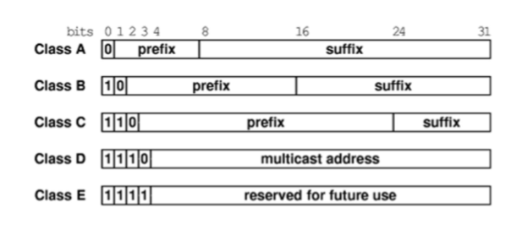

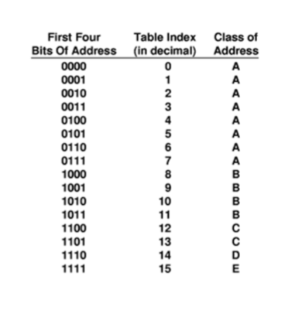

Two problems arose: either not enough hosts or so many host are being wasted

So two methods are used to overcome this, one is known as classless sub-classing or subnet masking.

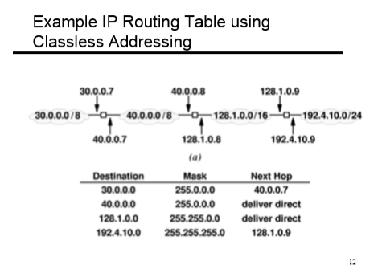

Classless allocation makes for more efficient subdivision.

Routers and multi-host have more than one ip address usually.

